**OUTLINE**

**INDOOR POSITIONING SYSTEM USING REGRESSION-BASED FINGERPRINT METHOD**



**RESEARCH**

*REGINALD PUTRA GHOZALI*

*1901788846*

**Graduate Program in Computer Studies**

**STUDY PROGRAM MASTER OF INFORMATION TECHNOLOGY**

**UNIVERSITAS BINA NUSANTARA**

**JAKARTA**

**2018**

* 1. **Background**

Indoor positioning has become popular research topic in current days as this system can be used for diverse purposes. Compared with outdoor positioning like Global Positioning System (GPS), that did not work in indoor environment, indoor positioning using Radio Frequency (RF) gives possibilities in indoor environment with limitation of bandwidth needed depending how large the indoor environment (Terán, Aranda, Carrillo, Mendez, & Parra, 2017). Current challenge when using Radio Frequency is estimating position using signal strength received, because radio frequency has weakness like disturbances from human body that affect radio signals (Topak, Pekeriçli, & Tanyer, 2018). Others are uncertainty of signal strength due to fast frequency received that needs waiting time to show different position of moving person (Contreras, Castro, & de la Torre, 2017) and random behavior of received signal strength (Terán, Aranda, Carrillo, Mendez, & Parra, 2017).

Many technologies have been used. Starting with optical type (infrared (Santo, Maekawa, & Matsushita, 2017) and visible light communication (Zhang, Chowdhury, & Kavehrad, 2014)), sounds (Moutinho, Araújo, & Freitas, 2016) (Yayan & Yucel, 2015), and radio-frequency (Wi-Fi (Thuong, Phong, Do, Van Hieu, & Loc, 2016) and Bluetooth (Faragher & Harle, 2015) (Faragher & Harle, 2014). Among them, Bluetooth low energy (BLE) has been used frequently by reasons of low cost, very low battery consumption, and high availability as supported by most modern smartphones.

BLE used 2.4 GHz unlicensed frequency (2402 to 2480 MHz) with total of 40 channels (2 MHz for each channel width). And using 3 channels for discovery services (channel 37, 38, 39) (Faragher & Harle, 2015) (Faragher & Harle, 2014). Many algorithms have been used for optimizing accuracy of the system. Such as multilateration and fingerprinting. Even so, there is not yet optimized solutions for high accuracy using BLE technology (Brena, et al., 2017).

There are many factor that affect the BLE radio propagation of the signals in indoor environments as BLE using radio signals, e.g., multipath effect, causing a random behavior in the Received Signal Strength (RSS) measurements caused by reflection (Terán, Aranda, Carrillo, Mendez, & Parra, 2017), movement rate of user (Topak, Pekeriçli, & Tanyer, 2018), and fast fading when measuring within a little time (Contreras, Castro, & de la Torre, 2017). To solve these problems, fingerprinting method is needed to estimate indoor position that needs estimation algorithm to ensure accuracy of position.

To get object’s location based on received signal strength from BLE, certain measurement method is needed. Current popular method is fingerprinting. Where localization algorithms used for measure or estimate location. It consists at least 2 steps: training step and determine position. Training step used to create a radio mapping of possible location from given signal strength received. While determine position step (Brena, et al., 2017) will match the received signals during online moments with radio mapping from previous step to determine object’s location. Older method to get object’s location using geometrical methods like trilateration (Rida, Liu, Jadi, Algawhari, & Askourih, 2015) to measure distance and position of person.

Many researchers tried to find optimized algorithm for indoor positioning. Some used k-nearest neighbor (Yu, et al., 2014) to estimate nearest points that can represent person’s position using classification, while certain researchers A few other tried regressions to estimate position like polynomial regression (Zhuang, Yang, Li, Qi, & El-Sheimy, 2016), where cumulative distribution function is related with error rate of average distance estimation. From these algorithms, regression model gives higher accuracy if compared with others. Given Polynomial Regression Model can solve multipath problems that gives random behavior of received signal strength (Zhuang, Yang, Li, Qi, & El-Sheimy, 2016).

Current state-of-the-art (Zhuang, Yang, Li, Qi, & El-Sheimy, 2016) is using Polynomial regression to calculate distance from fingerprinting position. Where RSS received processed using basic fingerprinting to get coordinate and using polynomial regression model to get distance. Both of them received using RSS signal from 3 advertisement channels of each beacons. then both result filtered using outlier detection to clean the result, by combine fingerprinting with polynomial regression model distance into combined distance. This filtered result will be processed using extended Kalman filtering using filtered distance from first outlier detection. Result from extended Kalman filtering will be filtered again using outlier detection to remove false measurement. This result then processed again with extended Kalman filtering into estimated position that will be compared with radio map to get the real position. This method is using distance-based measurement. Where the error rate is pretty high, caused by multipath effect and person movement rate, which is why the distance is filtered through many process mentioned in the method. Other weakness is it takes lots of calculation time.

This thesis intended to implement probabilistic method of fingerprinting using Deep Learning Convolutional Neural Networks Regression Model to estimate position of a person. The design consists of BLE beacons as signal transmitter, and mobile smartphone as signal receiver. Signal received in the device will be processed using fingerprinting method, then estimated by Convolutional Neural Networks (CNN) resulting an estimated position of a person.

* 1. **Problem Formulation**

Based from the introduction, the problems appeared in this research are represented using these questions:

1. How to design Indoor Positioning System using deep learning regression-based fingerprinting?
2. Does designed model gives high accuracy if compared with other methods?
   1. **Goals and Benefits**

The goals that will be claimed in this research are:

1. Develop regression-based fingerprinting model using deep learning CNN for Indoor Positioning System to compute location.
2. Evaluate the proposed method to find out increment of accuracy from the designed model.

With goals above, the benefits that will be received by the readers are:

1. Understand regression-based fingerprinting model for Indoor Positioning System.
2. Understand Convolutional Neural Networks.
3. Understand comparison of accuracy between proposed methods with other methods.
   1. **Scope of Work**

Scope of every works need to be done for the research are:

1. Design the proposed solution.
2. Development of the proposed solution using CNN.
3. Test and analyze solution at Bina Nusantara University, at room with size 21m x 12m.
4. Evaluate solution using RMSE.
   1. **Research Methodology**

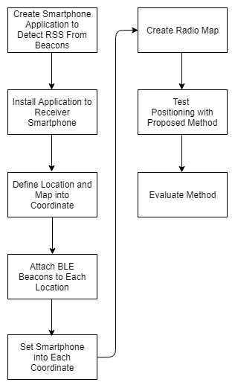

Figure 1. Research Process.

Research process to execute the research is shown in Figure 1. First, create mobile application (Android application) to receive RSS signal broadcasted by BLE transmitter (nRF51822 Bluetooth Smart Beacon Kit). Then, install the application into receiver smartphone. Now the smartphone is ready as RSS receiver. Next, create a coordinate map (Figure 2) based on each location that will be attached with beacon. These locations refer to real location where BLE transmitter attached, represented in coordinate map as reference points. After that, attach the beacons into the locations designated before (represented as access points). BLE transmitter will broadcast the RSS dispersedly. Then using the smartphone installed with application to receive the RSS and map them with position (x and y, inputted by user) of the smartphone in coordinate map. This process will create a database consists of x coordinate values, y coordinate values, and RSS values from each BLE beacons. The process will be repeated until all coordinates have their RSS values. A radio map will be created using this database to train and test the proposed method. The proposed method will be tested by applying the method in the online phase with radio map created to estimate position from person’s smartphone.

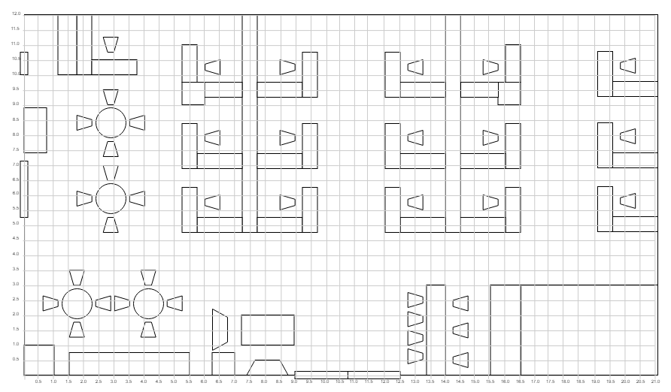

Figure 2. Coordinate Map.

**BIBLIOGRAPHY**

# 

Abuella, M., & Chowdhury, B. (2015). Solar power probabilistic forecasting by using multiple linear regression analysis. *SoutheastCon 2015* (pp. 1-5). IEEE.

Brena, R. F., García-Vázquez, J. P., Galván-Tejada, C. E., Muñoz-Rodriguez, D., Vargas-Rosales, C., & Fangmeyer, J. (2017). Evolution of indoor positioning technologies: A survey. *Journal of Sensors,2017*.

Čabarkapa, D., Grujić, I., & Pavlović, P. (2015). Comparative analysis of the bluetooth low-energy indoor positioning systems. *2015 12th International Conference on Telecommunication in Modern Satellite, Cable and Broadcasting Services (TELSIKS)*, (pp. 76-79).

Chai, T., & Draxler, R. R. (2014). Root mean square error (RMSE) or mean absolute error (MAE)?–Arguments against avoiding RMSE in the literature. *Geoscientific model development, 7*(3), 1247-1250.

Contreras, D., Castro, M., & de la Torre, D. S. (2017). Performance evaluation of bluetooth low energy in indoor positioning systems. *Transactions on Emerging Telecommunications Technologies, 28*(1), e2864.

Deng, L., & Yu, D. (2014). Deep learning: methods and applications. *Foundations and Trends® in Signal Processing, 7*(3-4), 197-387.

El-Sawy, A., Hazem, E. B., & Loey, M. (2016). CNN for handwritten arabic digits recognition based on LeNet-5. *International Conference on Advanced Intelligent Systems and Informatics* (pp. 566-575). Springer, Cham.

Esfe, M. H., Afrand, M., Yan, W. M., & Akbari, M. (2015). Applicability of artificial neural network and nonlinear regression to predict thermal conductivity modeling of Al2O3–water nanofluids using experimental data. *nternational Communications in Heat and Mass Transfer, 66*, 246-249.

Faragher, R., & Harle, R. (2014). An analysis of the accuracy of bluetooth low energy for indoor positioning applications. *Proceedings of the 27th International Technical Meeting of the Satellite Division of the Institute of Navigation (ION GNSS+’14)*, (pp. 201-210).

Faragher, R., & Harle, R. (2015). Location fingerprinting with bluetooth low energy beacons. *IEEE journal on Selected Areas in Communications, 33*(11), 2418-2428.

Gentile, C., Alsindi, N., Raulefs, R., & Teolis, C. (2012). *Geolocation techniques: principles and applications.* Springer Science & Business Media.

Goodfellow, I., Bengio, Y., Courville, A., & Bengio, Y. (2016). *Deep learning* (Vol. 1). Cambridge: MIT press.

He, S., & Chan, S. H. (2016). Wi-Fi fingerprint-based indoor positioning: Recent advances and comparisons. *IEEE Communications Surveys & Tutorials, 18*(1), 466-490.

Hoo-Chang, S., Roth, H. R., Gao, M., Lu, L., Xu, Z., Nogues, I., . . . Summers, R. M. (2016). Deep convolutional neural networks for computer-aided detection: CNN architectures, dataset characteristics and transfer learning. *IEEE transactions on medical imaging, 35*(5), 1285.

Kuo, Y. S., Pannuto, P., Hsiao, K. J., & Dutta, P. (2014). Luxapose: Indoor positioning with mobile phones and visible light. *Proceedings of the 20th annual international conference on Mobile computing and networking* (pp. 447-458). ACM.

Moutinho, J. N., Araújo, R. E., & Freitas, D. (2016). Indoor localization with audible sound—Towards practical implementation. *Pervasive and Mobile Computing, 29*, 1-16.

Rida, M. E., Liu, F., Jadi, Y., Algawhari, A. A., & Askourih, A. (2015). Indoor location position based on bluetooth signal strength. *Information Science and Control Engineering (ICISCE), 2015 2nd International Conference* (pp. 769-773). IEEE.

Santo, H., Maekawa, T., & Matsushita, Y. (2017). Device-free and privacy preserving indoor positioning using infrared retro-reflection imaging. *Pervasive Computing and Communications (PerCom), 2017 IEEE International Conference*, (pp. 141-152).

Terán, M., Aranda, J., Carrillo, H., Mendez, D., & Parra, C. (2017). IoT-based system for indoor location using bluetooth low energy. In IEEE (Ed.), *Communications and Computing (COLCOM), 2017 IEEE Colombian Conference*, (pp. 1-6).

Thuong, N. T., Phong, H. T., Do, D. T., Van Hieu, P., & Loc, D. T. (2016). Android application for WiFi based indoor position: System design and performance analysis. *Information Networking (ICOIN), 2016 International Conference* (pp. 416-419). IEEE.

Topak, F., Pekeriçli, M. K., & Tanyer, A. M. (2018). Technological Viability Assessment of Bluetooth Low Energy Technology for Indoor Localization. *Journal of Computing in Civil Engineering, 32*(5), 04018034.

Townsend, K., Cufí, C., & Davidson, R. (2014). *Getting started with Bluetooth low energy: tools and techniques for low-power networking.* O'Reilly Media, Inc.

Tuncer, S., & Tuncer, T. (2015). Indoor localization with bluetooth technology using artificial neural networks. *Intelligent Engineering Systems (INES), 2015 IEEE 19th International Conference* (pp. 213-217). IEEE.

Xu, H., Wu, M., Li, P., Zhu, F., & Wang, R. (2018). An RFID Indoor Positioning Algorithm Based on Support Vector Regression. *Sensors, 18*(5), 1504.

Yayan, U., & Yucel, H. (2015). A low cost ultrasonic based positioning system for the indoor navigation of mobile robots. *Journal of Intelligent & Robotic Systems, 78*(3-4), 541-552.

Yu, F., Jiang, M., Liang, J., Qin, X., Hu, M., Peng, T., & Hu, X. (2014). 5 G WiFi Signal-Based Indoor Localization System Using Cluster k-Nearest Neighbor Algorithm. *International journal of distributed sensor networks, 10*(12), 247525.

Zhang, W., Chowdhury, M. S., & Kavehrad, M. (2014). Asynchronous indoor positioning system based on visible light communications. *Optical Engineering, 53*(3), 045105.

Zhuang, Y., Yang, J., Li, Y., Qi, L., & El-Sheimy, N. (2016). Smartphone-based indoor localization with bluetooth low energy beacons. *Sensors, 16*(5), 596.